**Windows Subsystem for Linux Installation Guide for Windows 10**

* 07/22/2018
* 2 minutes to read

**Install the Windows Subsystem for Linux**

Before installing any Linux distros for WSL, you must ensure that the "Windows Subsystem for Linux" optional feature is enabled:

1. Open PowerShell as Administrator and run:

PowerShell Copy

Enable-WindowsOptionalFeature -Online -FeatureName Microsoft-Windows-Subsystem-Linux

1. Restart your computer when prompted.

**Install your Linux Distribution of Choice**

To download and install your preferred distro(s), you have three choices:

* Download and install from the Microsoft Store (see below)
* Download and install from the Command-Line/Script ([read the manual installation instructions](https://docs.microsoft.com/en-us/windows/wsl/install-manual))
* Download and manually unpack and install (for Windows Server - [instructions here](https://docs.microsoft.com/en-us/windows/wsl/install-on-server))

**Windows 10 Fall Creators Update and later: Install from the Microsoft Store**

This section is for Windows build 16215 or later. Follow these steps to [check your build](https://docs.microsoft.com/en-us/windows/wsl/troubleshooting#check-your-build-number).

1. Open the Microsoft Store and choose your favorite Linux distribution.

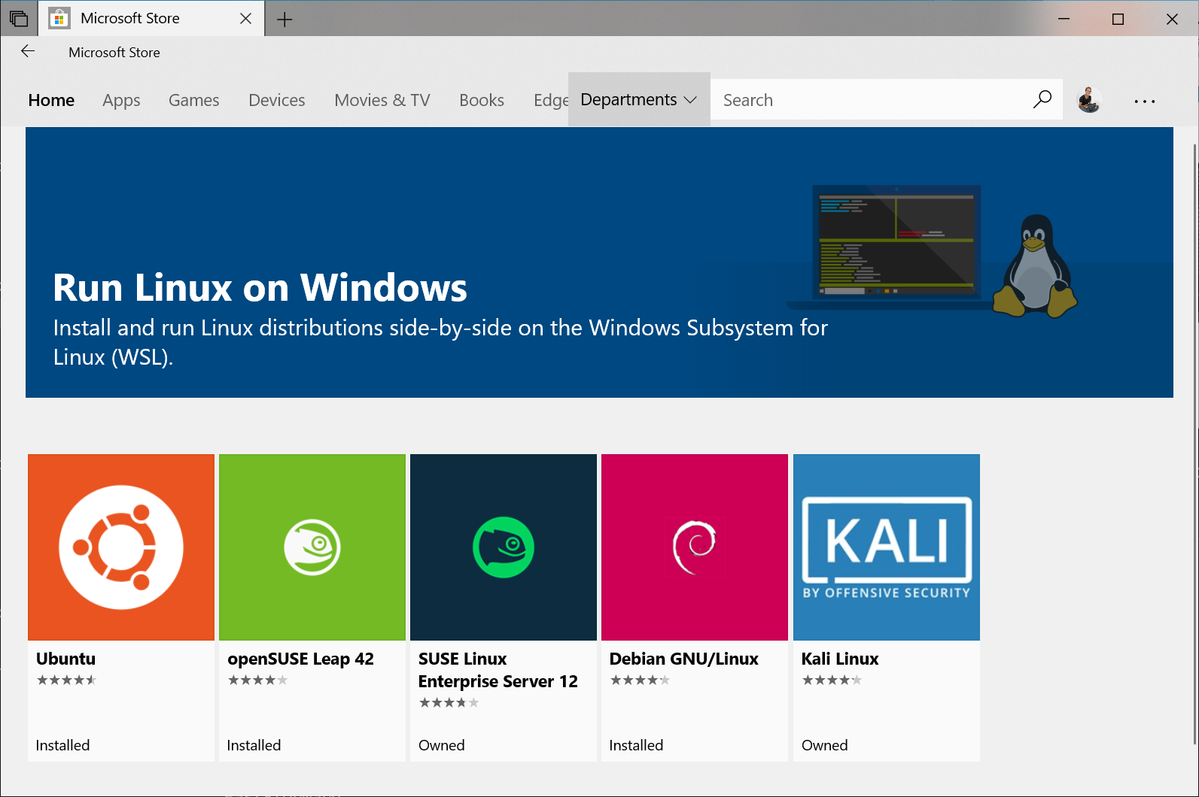

The following links will open the Microsoft store page for each distribution:

* + [Ubuntu 16.04 LTS](https://www.microsoft.com/store/apps/9pjn388hp8c9)
  + [Ubuntu 18.04 LTS](https://www.microsoft.com/store/apps/9N9TNGVNDL3Q)
  + [OpenSUSE Leap 15](https://www.microsoft.com/store/apps/9n1tb6fpvj8c)
  + [OpenSUSE Leap 42](https://www.microsoft.com/store/apps/9njvjts82tjx)
  + [SUSE Linux Enterprise Server 12](https://www.microsoft.com/store/apps/9p32mwbh6cns)
  + [SUSE Linux Enterprise Server 15](https://www.microsoft.com/store/apps/9pmw35d7fnlx)
  + [Kali Linux](https://www.microsoft.com/store/apps/9PKR34TNCV07)
  + [Debian GNU/Linux](https://www.microsoft.com/store/apps/9MSVKQC78PK6)
  + [Fedora Remix for WSL](https://www.microsoft.com/store/apps/9n6gdm4k2hnc)
  + [Pengwin](https://www.microsoft.com/store/apps/9NV1GV1PXZ6P)
  + [Pengwin Enterprise](https://www.microsoft.com/store/apps/9N8LP0X93VCP)
  + [Alpine WSL](https://www.microsoft.com/store/apps/9p804crf0395)

1. From the distro's page, select "Get"

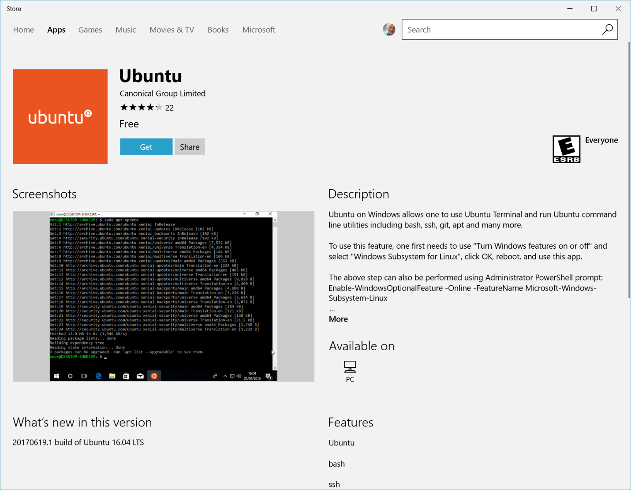

**Complete initialization of your distro**

Now that your Linux distro is installed, you must [initialize your new distro instance](https://docs.microsoft.com/en-us/windows/wsl/initialize-distro) once, before it can be used.

**Troubleshooting:**

Below are related errors and suggested fixes. Refer to the [WSL troubleshooting page](https://docs.microsoft.com/en-us/windows/wsl/troubleshooting) for other common errors and their solutions.

* **Installation failed with error 0x80070003**
  + The Windows Subsystem for Linux only runs on your system drive (usually this is your C: drive). Make sure that distros are stored on your system drive:
  + Open **Settings** -> **Storage** -> **More Storage Settings: Change where new content is saved** 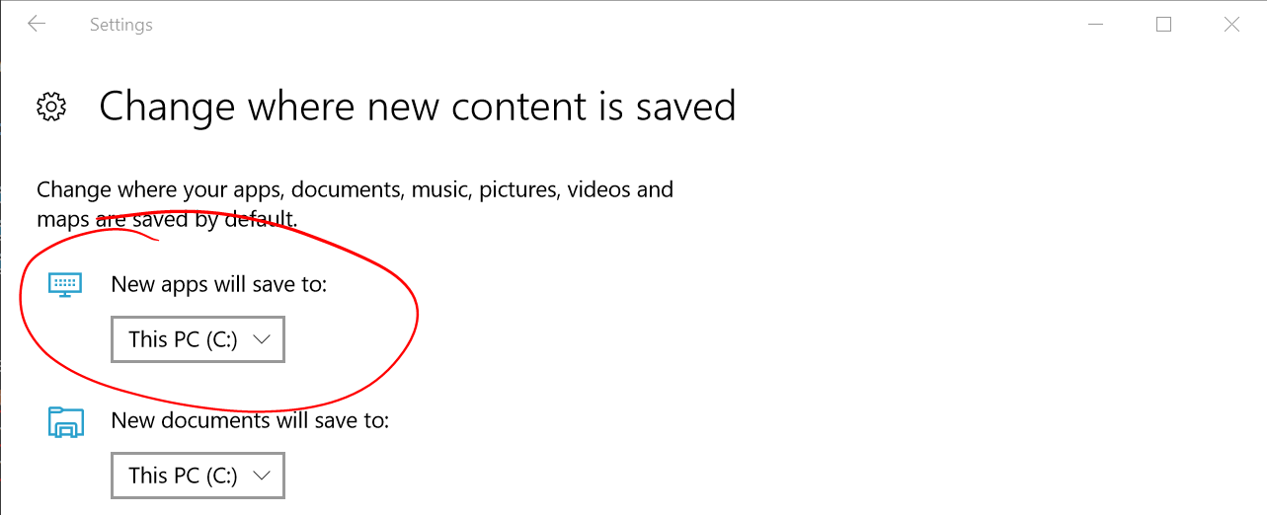
* **WslRegisterDistribution failed with error 0x8007019e**
* The Windows Subsystem for Linux optional component is not enabled:
* Open **Control Panel** -> **Programs and Features** -> **Turn Windows Feature on or off** -> Check **Windows Subsystem for Linux** or using the PowerShell cmdlet mentioned at the begining of this article.